

Microsoft Partner

Gold Cloud Platform

Gold Devices and Deployment

Gold Application Lifecycle Management

Gold Application Development

Gold Cloud Productivity

Deploy feature updates to PC using Intune

**Prepared By: NathCorp**

**Team Detail**

Neeraj Kumar

**In the guidance of:**

Pranay Kumar

Dhanraj Barman

**Description:**

Deploy feature updates to the PC devices using Intune

**Contents**

Client Specification…………………………………………………………………………………………………….. 2

Requirement………………………………………………………………………………………………………….…. 2

Hardware Requirements……………………………………………………………………………….. 2

Software Requirements……………………………………………………………………………….…. 2

Implementation………………………………………………………………………………………………………... 2

Environment Setup………………………………………………………………………………………... 2

Use EMCO MSI Package Builder…………………………………………………………………...… 3

Limitations of using free version……………………………………………………….. 7

Advantages of using paid version……………………………………………………… 7

Use PE tool in CMD………………………………………………………………………………………... 7

Split .wim file……………………………………………………………………………………… 7

Rebuild .wim file……………………………………………………………………………….. 8

Use IExpress………………………………………………………………………………………………….. 8

Run Setup Silently………………………………………………………………………………………… 15

Adding Applications……………………………………………………………………………………… 15

Deploying Applications………………………………………………………………………………… 19

User Experience……………………………………………………………………………………………….……… 21

# Client Specification

**OS**: Microsoft Windows 10 Enterprise, Version 1703 (OS Build 15063.674)

**Processor**: Intel (R) Core(TM) i5-6300U CPU @2.40GHz, 2 Core(s), 4 Logical processor

**System type**: 64-bit OS

**RAM**: 4GB

**HDD**: 127 GB

# Requirement

## Hardware Requirements

**Processor**:1 gigahertz (GHz) or faster processor

**RAM**: 3 gigabyte (GB)

**Free Hard disk space**: 20 GB

## Software Requirements

* W10-1709 ISO
* EMCO MSI package Builder
* IExpress

# Implementation

1. Download W10-1709 ISO
2. Break and Convert it into required chunks of MSI File
3. Deploy these MSI packages to the devices
4. Deploy command line/EXE to run setup file to initiate Feature Update Silently

## Environment setup

* Create an Intune Credential
* Download Client Software
* Install W10-1703
* Install downloaded Client Software on PIDs
* Create device group and add these devices in it

## Use EMCO MSI Package Builder

**To create MSI of files/folders of ISO contents, we can use this tool**

1. Create new project

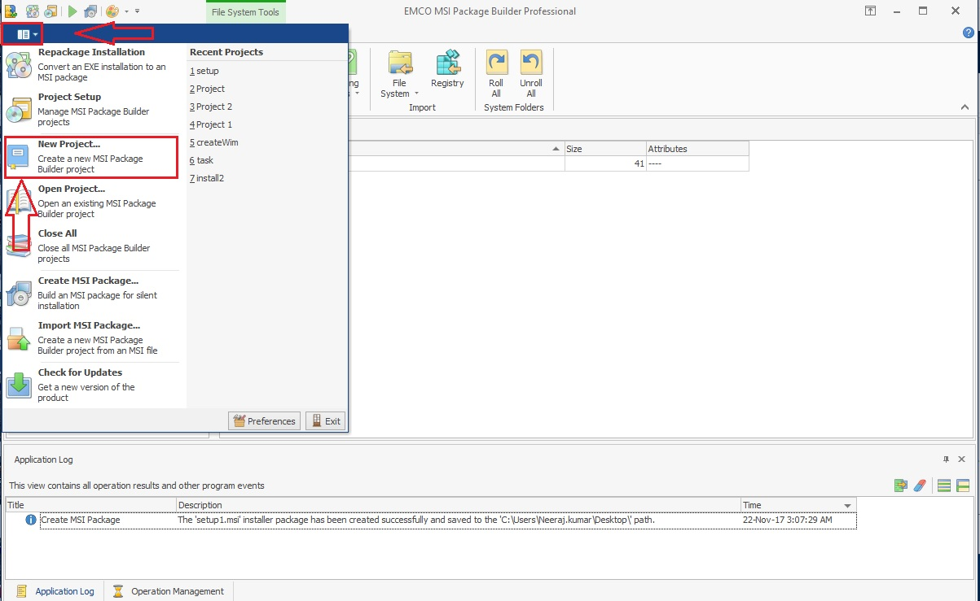

You will get the following window, give your project name and click **Ok**

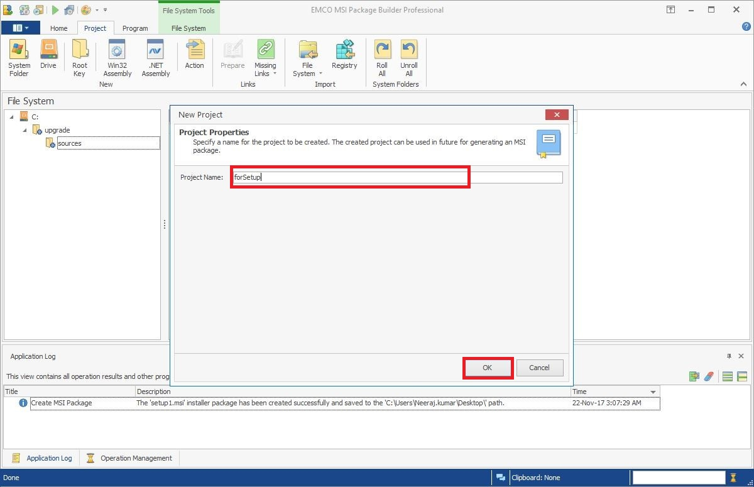

1. Now, mention ‘product name’ and ‘manufacturer’

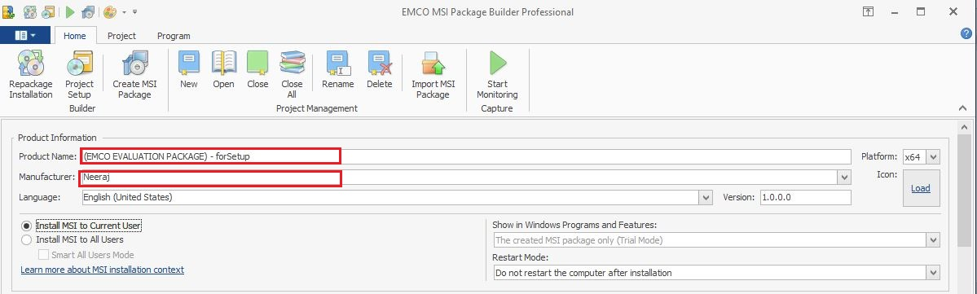

1. Click on ‘Project’ tab

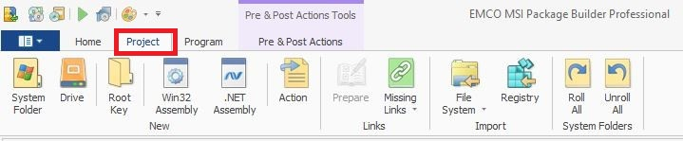

1. Click on ‘Home’ tab.
2. Select the drive you want your MSI to be installed on client side.

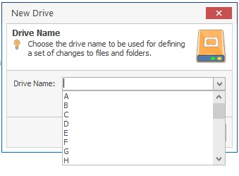

1. It will open new window, right click under right pane, you will find option to new file/folder

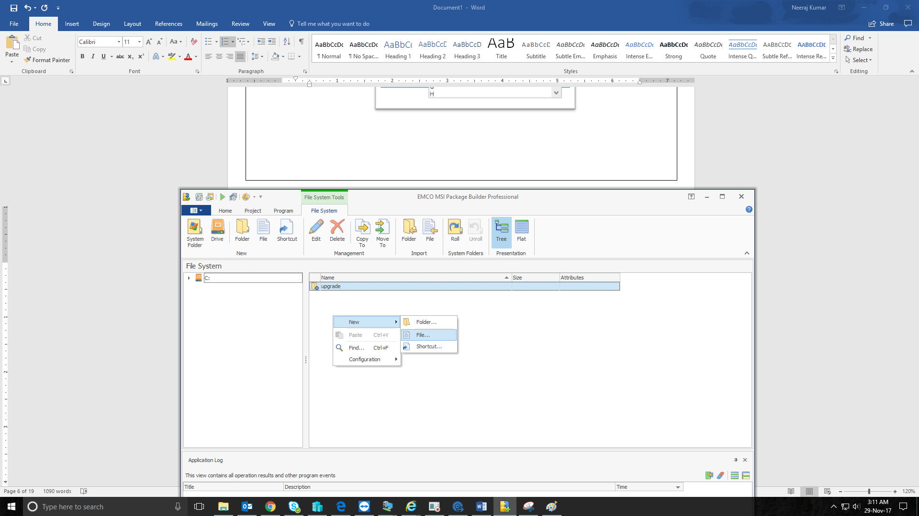

Or you can add folders by just clicking on **Folder** on file system. After, giving folder name, click **Ok**

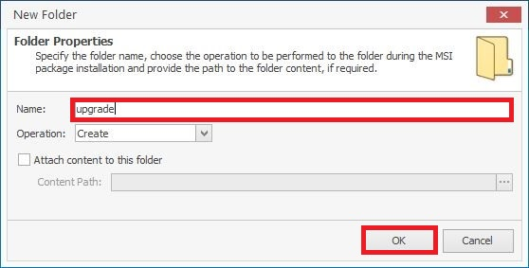

You can check on “attach content to this folder” for adding subfolders.

1. Add files you want to add in this package by browsing the files

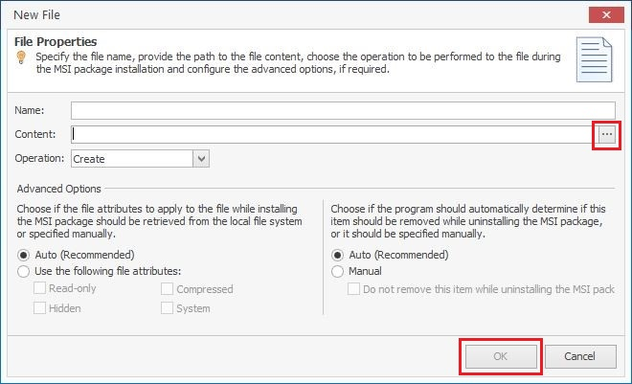

1. Click on ‘Create MSI package’ under ‘Home’ Tab

Choose MSI destination location in ‘MSI Path’ where you want prepared MSI package

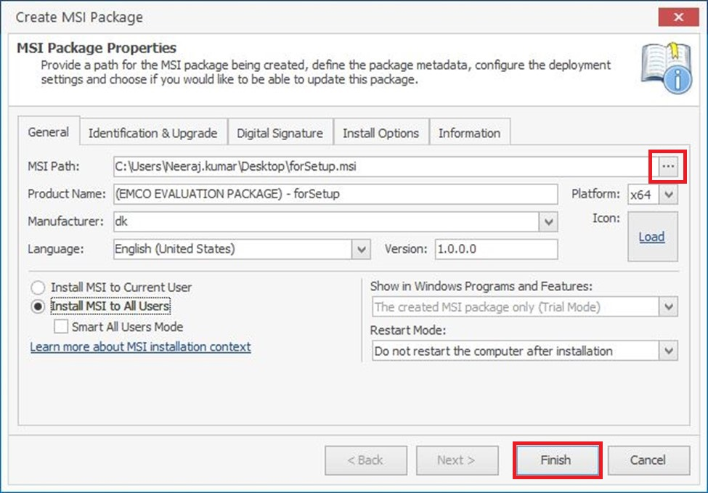

Create MSI packages as many as required (keeping figures in mind)

Limitations of using free version  
Using free version, we can make as many MSI packages. But, since it is a trial version the package cannot be used after one month.

The error when tried installing after trial version expiration:

*"Trial version of this product has expired".*

And also after a month, you could not open EMCO application to create more MSI packages.

### Advantages of using paid version

1. Distribute and Deploy Software and Updates Remotely
2. Convert Existing Installations into MSI Packages for Remote Deployment
3. Use Most Advanced Technology for Installations Repackaging
4. Customize Existing Installations
5. Transform Any Activity into MSI Package
6. Build Your First MSI in Less Than 10 Minutes

*Main features of EMCO package builder:*

* Create MSI packages
* Build silent MSI packages (No activity required by user)
* Convert EXE to MSI (EXEs sometimes failed to install on client, after conversion this issue will not be longer)
* Customize existing installation (such as forcing installation in desired location, creating/checking registry)

In addition, I have found one more advantages of using EMCO over others are:

**Using Visual Editors**, only way to create MSI is manual creation also it requires in-depth knowledge of windows.

**Using Monitoring in EMO**, we can create automate the creation of MSI packages.

## Use PE tool in CMD

### Split .Wim file

1. Determine the size of media required for the image.
2. Create a batch file and write the following:

**Dism/Split-Image**/ImageFile:D:\install.wim/SWMFile:C:\upgrade\install.swm /FileSize:1224

where:

* D:\install.wim is the name and the location of the image file that you want to split.
* C:\upgrade\install.swm is the destination name and the location for the split .Wim files.
* 1224 is the maximum size in MB for each of the split .Wim files to be created.

In this example, the /split option creates an install.swm file, an install2.swm file, an install3.swm file, and so on, in the D:\Imaging directory.

Now, create MSI of these SWF files with MSI package Builder.

### Rebuild .Wim file

**Create batch file that will run DISM command as administrator to rebuild install.wim**

*powershell-Command"Start-processcmd\" /k DISM /Export-Image /SourceImageFile: C:\upgrade\install.swm /swmfile: C:\upgrade\install*.swm /SourceIndex:1 /DestinationImageFile: C:\upgrade\sources\install.wim\" -Verb RunAs"*

Now, create EXE of this BAT file using IExpress.

## Use IExpress

**Create EXE of this batch file using inbuilt tool from Windows**

1. Press **Win+R** to open run command
2. Write IExpress and click ‘**Ok**’:

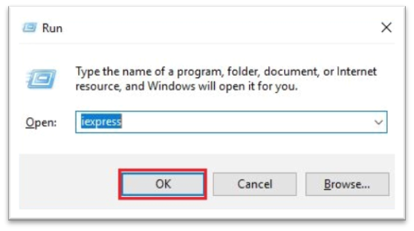

1. In the dialogue window, choose: “Create new Self Extraction Directive file “, click **Next:**

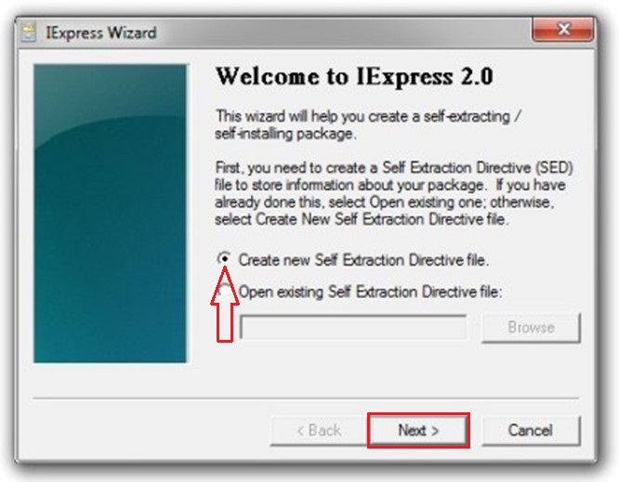

1. Select “Extract files and run an installation command”:

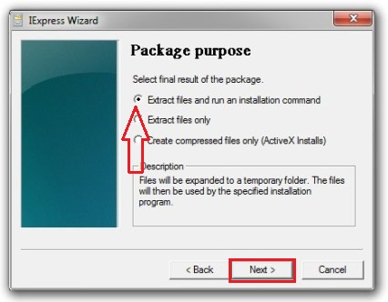

1. Now, we you will be asked to give your project a name. Then Continue by clicking **Next**:

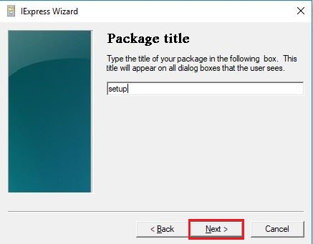

1. Select “No prompt” in configuration prompt:

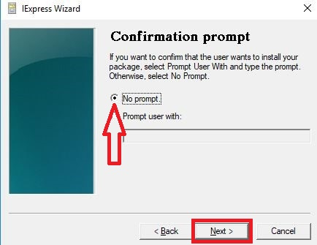

1. Select “Do not display a license” in license agreement:

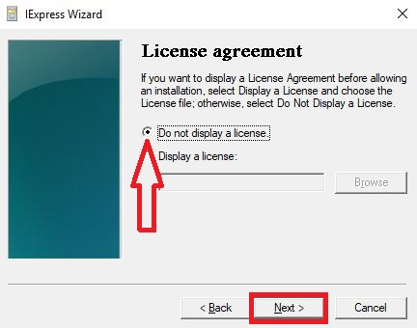

1. At this point we are to add the batch-file, after adding click **Next**

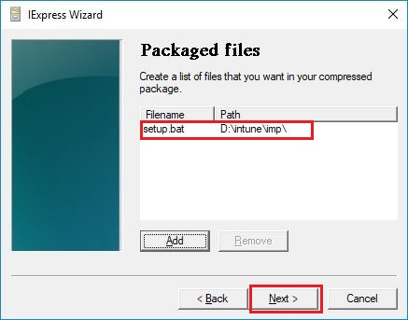

1. Specify a command for application installation and click **Next**.

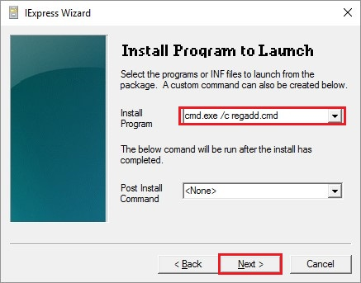

1. Run the command in the “hidden” mode:

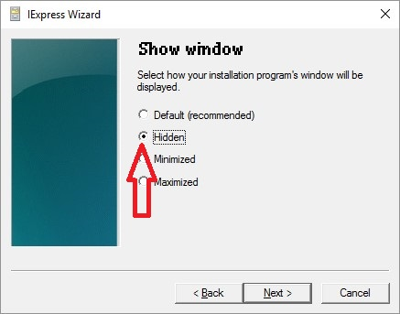

1. We don’t need some messages after installation is complete, so select “No Message”:

[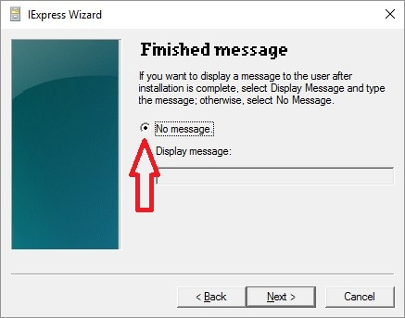](http://liashov.com/?attachment_id=3751)

1. Specify target path for your package by clicking on **Browse:**

[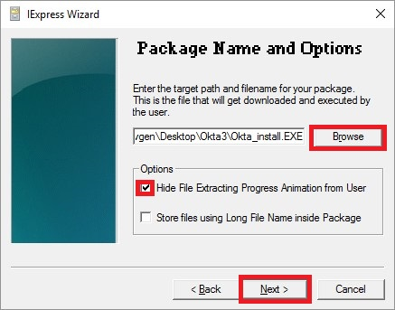](http://liashov.com/?attachment_id=3752)

1. Select if restart is required/not required:

[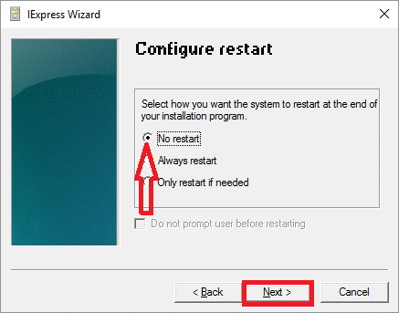](http://liashov.com/?attachment_id=3753)

1. Also, you can save configuration file if you need to modify a package later, I have selected “Don’t save”. Click **Next:**

[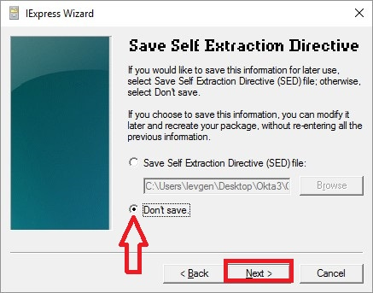](http://liashov.com/?attachment_id=3754)

1. Click **Next:**

[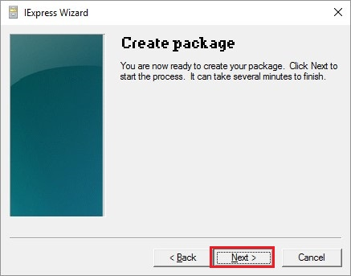](http://liashov.com/?attachment_id=3755)

1. Click **Finish**:

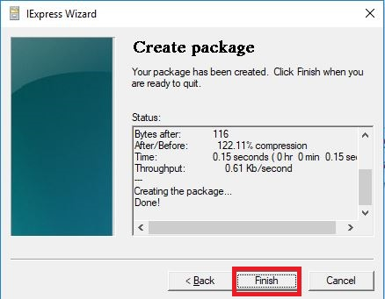

## Run Setup Silently

**For setup.exe to run silently for Windows Upgradation**

Command to write in batch file

Command- *c:\upgrade\setup.exe /auto upgrade /quiet*

Now, create EXE of batch file using IExpress.

## Adding Applications

Use the Intune Software Publisher to configure the properties of the app and upload it to your cloud storage space by using the following procedure:

1. In the Microsoft Intune administrator console, choose **Apps** > **Add Apps** to start the Intune Software Publisher:

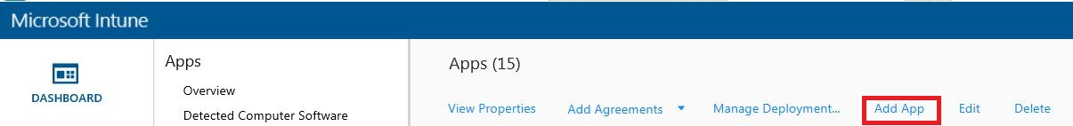

A window will open that will ask for the credentials, login with user that can upload application:

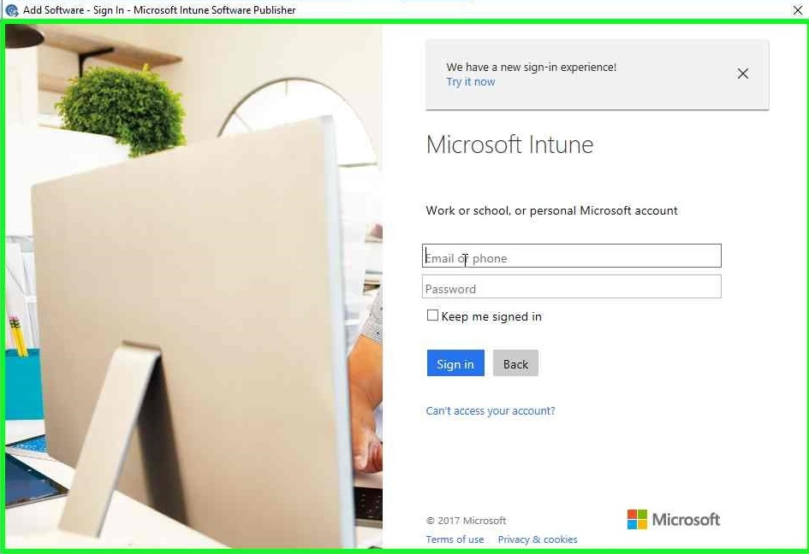

1. Click **Next:**

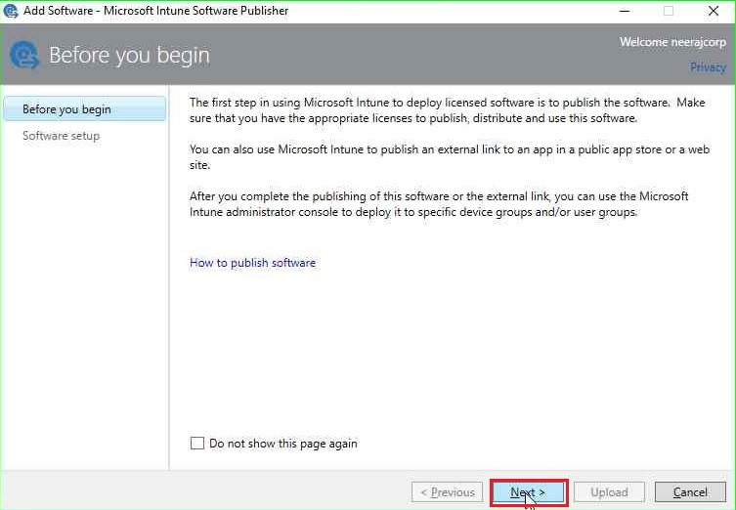

1. On the Software setup page of the publisher, under Select how this software is made available to devices, choose **Software installer**, and then specify:

* Select the software installer file type. This indicates the type of software that you want to deploy. For a Windows PC, choose **Windows Installer**.
* Specify the location of the software setup files. Enter the location of the installation files, or choose **Browse** to select the location from a list. Then click **Next**:

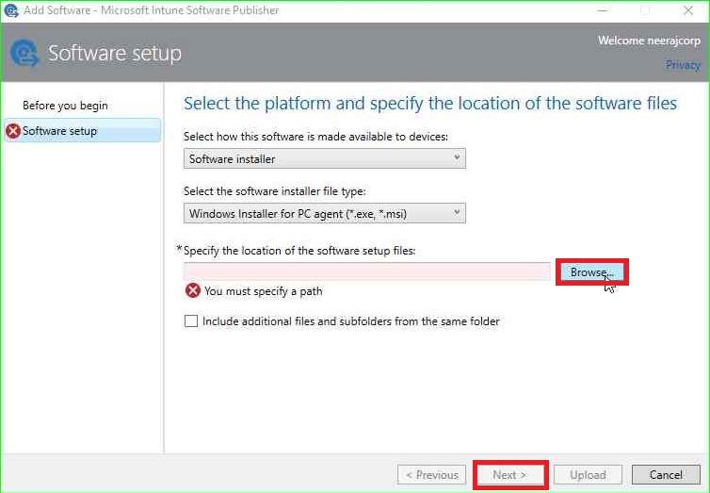

1. On Software description page, add Publisher, Name, Description. Then click **Next**:

* **Publisher**: Enter the name of the publisher of the app.
* **Name**: Enter the name of the app as it will be displayed in the company portal.
* **Description:** Enter a description for the app. This will be displayed to users in the company portal.

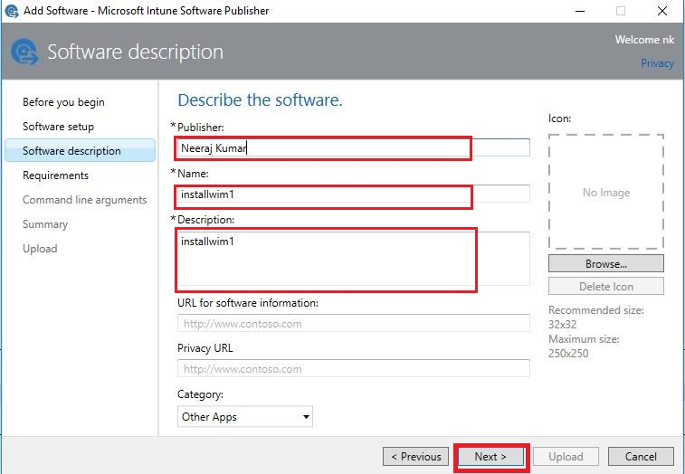

1. On Requirements page, select the requirements that must be met before the app can be installed. Choose from:

* **Architecture**: Select whether this app can be installed on 32-bit, 64-bit, or both operating systems.
* **Operating System:** Select the minimum operating system on which this app can be installed.

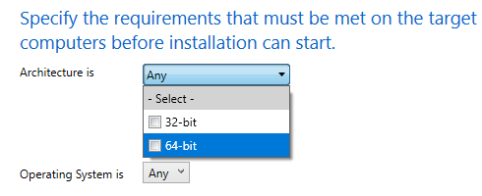

I have selected “Any” in this case.

1. For the Windows Installer file type only (.msi and .exe): On the Command line arguments page, choose whether you want to supply optional command-line arguments for the installer. The following parameters are added automatically by Intune:

* For .exe files, /install is added.
* For .msi files, /quiet is added.

Select **No** and click **Next**:

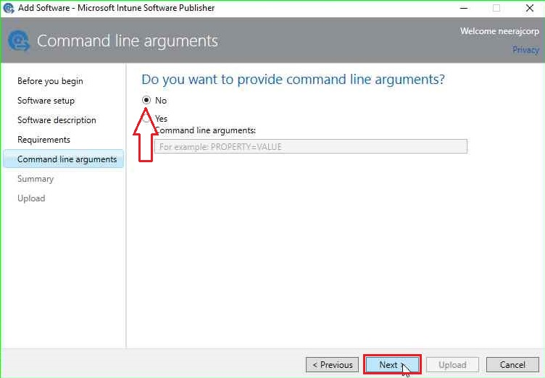

1. On the Summary page, review the information that you specified. When you are ready, choose Upload:

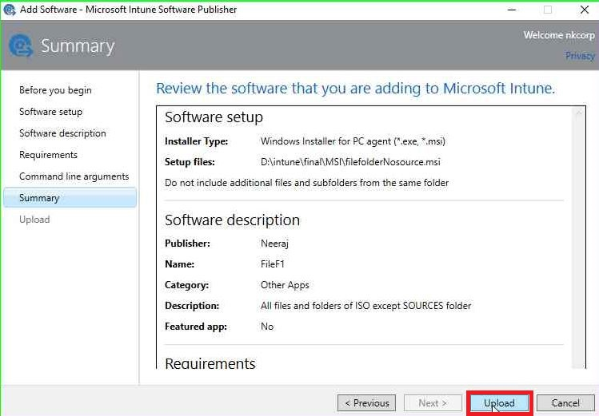

1. Choose Close to finish:

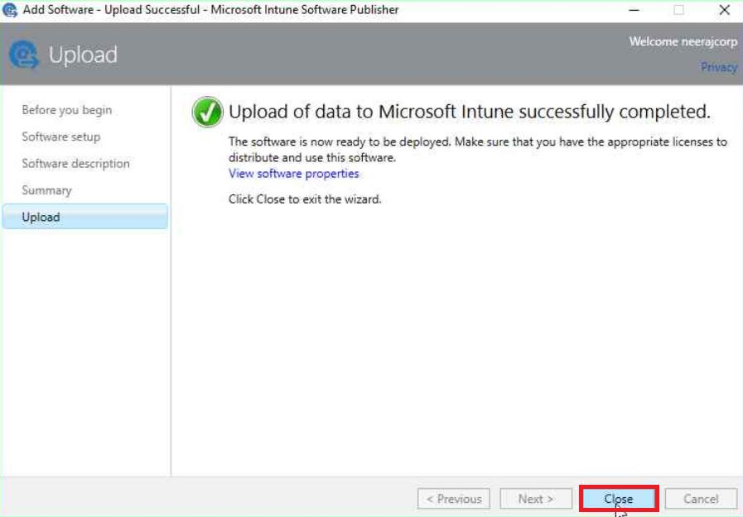

## Deploying Applications

1.Select the app, right click on it. Click on Manage Deployment:

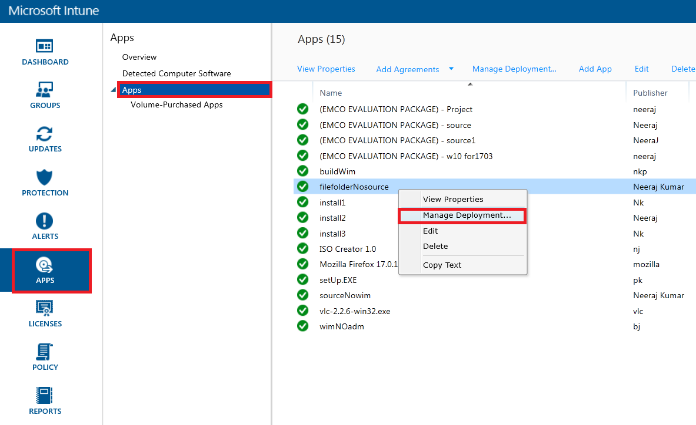

2.Select device group/groups from left side of window and click on “Add”:

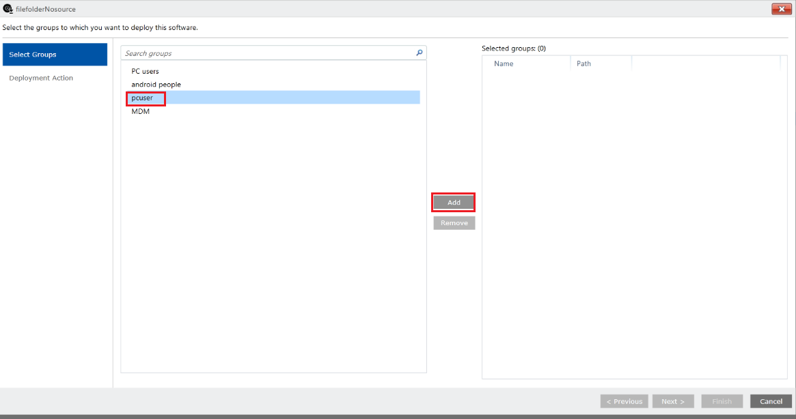

Once added, you will see selected groups on right side of same window. Now, click **Add** and **Next:**

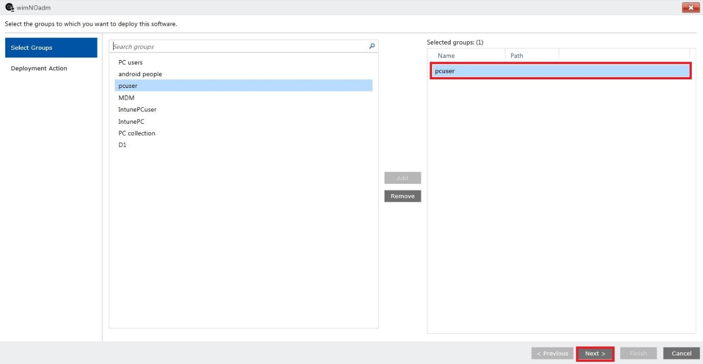

1. On Deployment action page, select required install in deployment type.

Select deadline “As soon as possible”. Then, Click **Finish:**

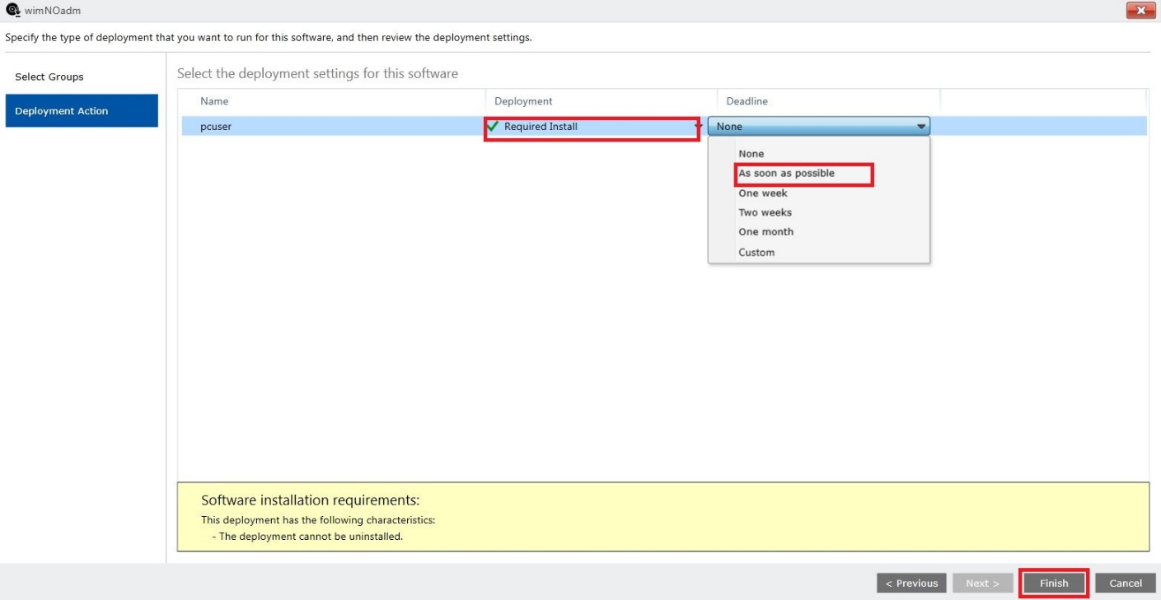

# User Experience

## Method 1

**Package download and installation automatically.**

There is” NO” action required by the user, as every package will be installed silently (i.e. complete silent installation of packages). **NO UI**, **NO PROMPT**, user can use his system as usual and installation will be done in backend. Only there is two requirements:

* Keep the device Turned ON.
* Have good internet connection.

The upgradation will auto-start automatically after restarting of the device.

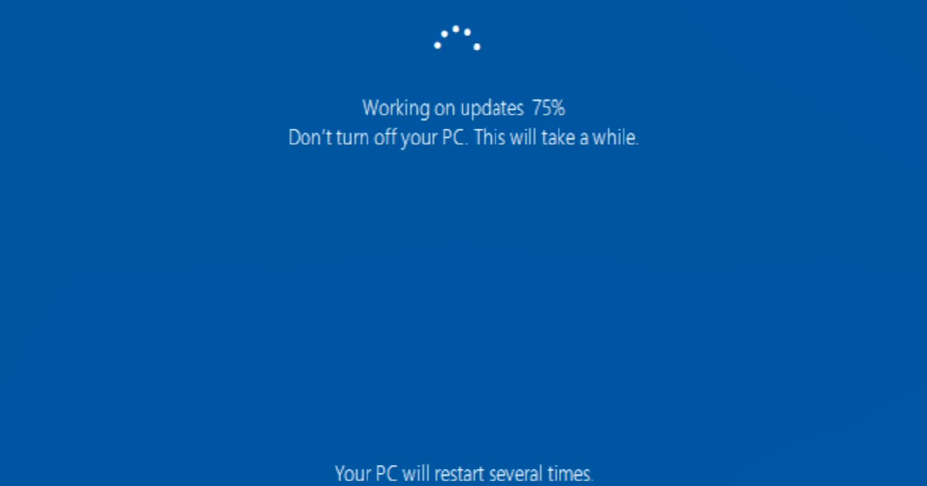

## Method 2

**Manual, if user need it urgently.**

Once deployed, these packages will be available as Updates which can be found in Microsoft Intune Center.For manual upgradation, user need to follow these steps:

### Steps required

1.Client can find Microsoft Intune center by pressing window button which is in bottom-left corner of window:

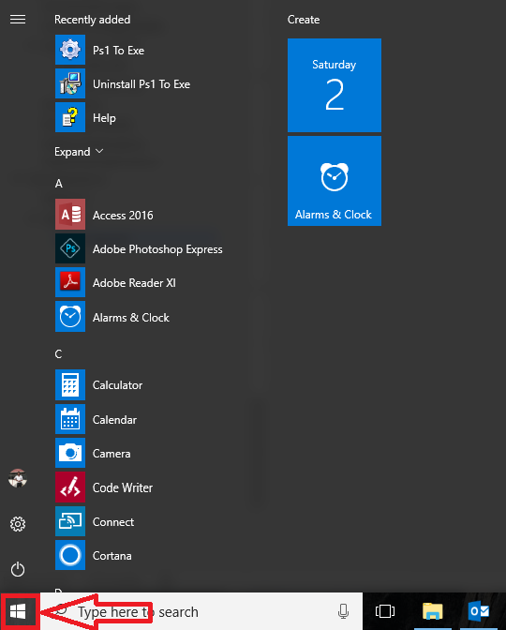

2.Click on any alphabet, you will get screen like:

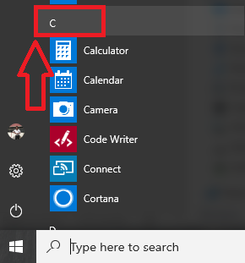

3.Click on letter “M”:

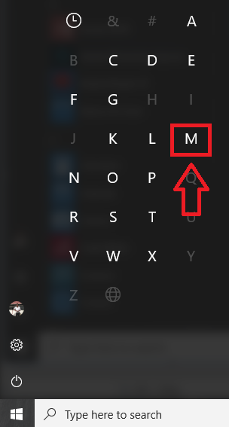

4.Find and click on “Microsoft Intune Center”:

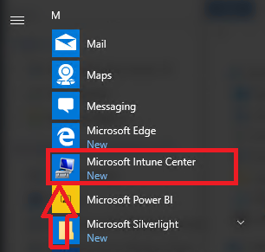

5.Now, click on “check for updates”:

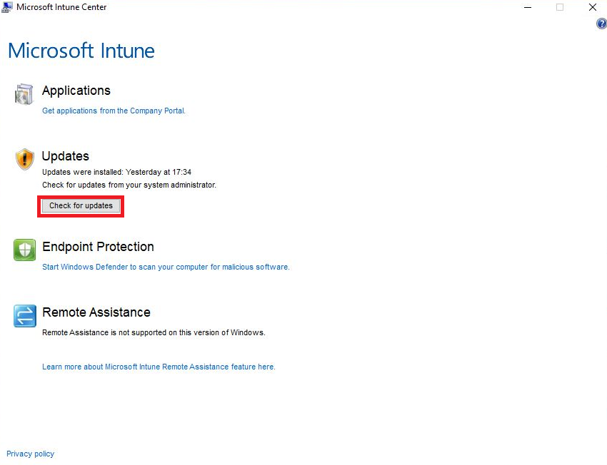

6.After clicking on check for updates, it will show updates are available. Client need to click on “Install Updates”:

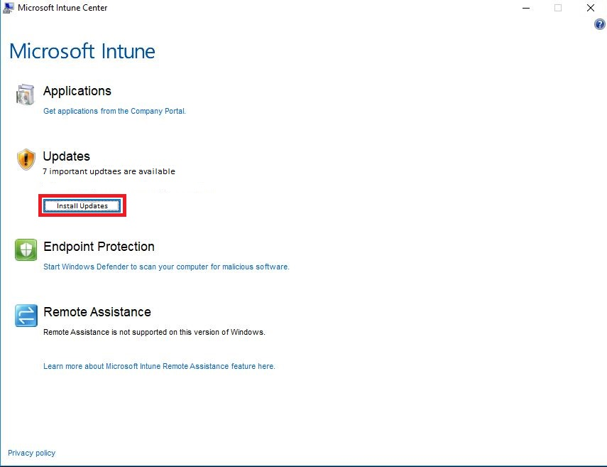

Once it is clicked, prompt that will come for the confirmation. Click on “Install”:

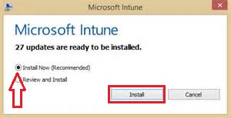

After every package will be installed in the backend, on next login/restart of system, it will automatically install updates for upgradation of windows version.

The following screen will come after next start:



After successful installation, you can find windows version will change.

To check this, press **Win+R,** write **winver** and press enter.

